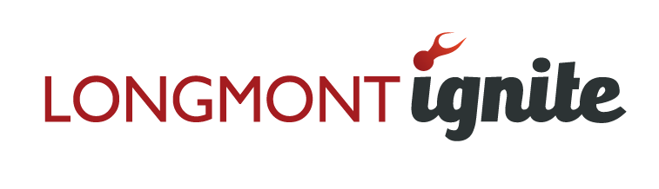

Longmont Ignite is a group of community minded individuals who have established a fund to make grants to entrepreneurs developing products or business concepts that will add to the economic vitality of the Longmont area. Entrepreneurs who receive grants will be asked to commit to return some of any profit they may make from their project to the fund. Ignite members will listen to business pitches, develop the process for recommending grants, and provide suggestions on increasing the Fund. Additionally, on an individual basis, some of the members may wish to provide mentoring for the funded and prospective projects.
If you are interested in being considered for a Longmont Ignite grant, please complete the short application below.

- What is your idea?

- What will you do with funding?

- What do you see as your potential market? What is your growth strategy, and how do you expect to scale your business?

- What stage of the life cycle is your business currently in (e.g. early, mid, late)?

- Who is on the team? Please provide us with some background information on the founder and key team members.

- How much money have you kicked in yourself? Have you been able to obtain any additional funding? Please provide details.

- If you receive funding and generate a profit from your business idea, you will be asked to return a donation to the Longmont Ignite Fund so that we can provide opportunities to future entrepreneurs. How will you give back to Longmont Ignite?

